**DoorGame Documentation**

**By Chris Ricchi**

**Introduction**

Welcome to the DoorGame program, a simple simulation of the Monty Hall problem! The Monty Hall problem is a probability puzzle which involves choosing one door out of three in hopes of choosing the one that has a prize behind it. This documentation will guide you through the implementation and testing of the program and demonstrate how it functions.

**Using DoorGame**

The program simulates three doors, one of which has a prize behind it. The idea behind the simulation is to calculate the probability of winning based on whether you decide to stick with your initial choice, or switch to a different choice afterwards. This simulation is not a functional game, but rather a determination of the probability of winning based on switching.

**Understanding the Results**

DoorGame will run 20,000 total simulations of the Monty Hall program where 10,000 of them are the result of switching after the initial choice and the other 10,000 of them are without switching after the initial choice. The purpose of these simulations is to determine if there is a higher probability of winning the game if you decide to switch or not. Based on the results of the 10,000 simulations, the player wins approximately 67.16% of games when switching, and only 32.82% of games when not switching. Therefore, a player of the Monty Hall problem would have a much higher percentage chance of winning a game if they decided to switch doors after their initial choice.

**In-Depth Results**

Based on the results of the program, you can see that the percentage of games won while switching doors is much higher than games won when not switching doors. Below, you will see the output of the simulation as well as a visualization of the results.

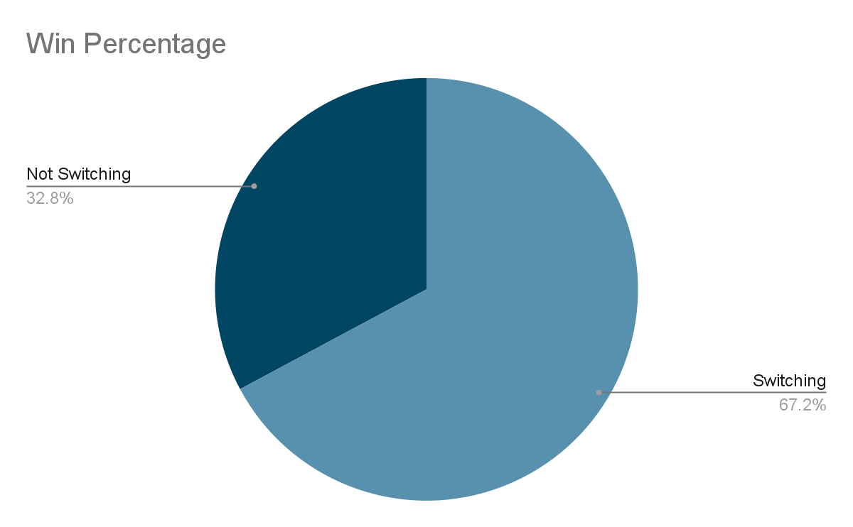**Win Percentage Visual Representation**